**Call for Sponsors 2025**

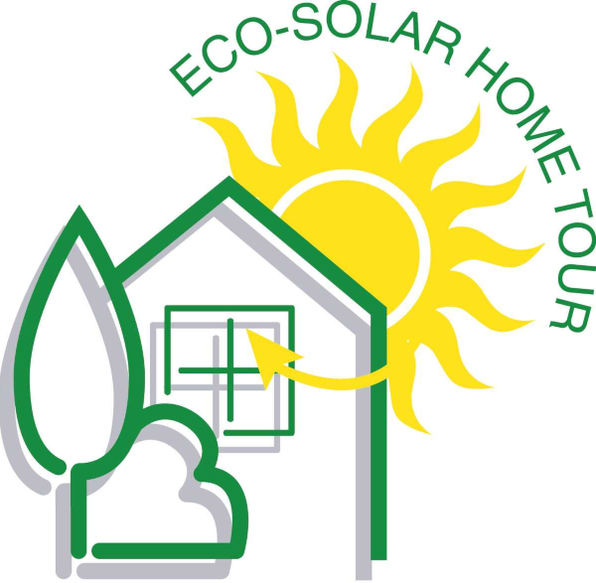

It’s time for the leaders of the energy-efficient home industry to show their support for the Eco-Solar Home tour for 2025. We are signing up sponsors between now and January 31st for our 2025 Tour. Sponsors are listed in the order their request is received so email me as soon as possible please. To sign up, simply email me indicating your preferred sponsorship level before January 30th



The Eco-Solar Home Tour Society is presenting 3 cities this year: Edmonton, Calgary, and Lethbridge.

Contact the Biosphere Institute for the Canmore tour <https://www.biosphereinstitute.org/>.

For Edmonton, Calgary and Lethbridge the sponsorships levels for the 2025 Tour are: $600 for Bronze, $1200 for Silver, and $2400 for Gold. The Eco-Solar Tour offers a 50% discount for your second and third sponsorships in other cities, i.e., a bronze sponsorship in both Edmonton and Calgary would be $900 (1.5 x $600).

We will require a good quality image of your current logo and a write up on your organization. I suggest you review the previous writeups on our sponsor page for guidance at [www.ecosolar.ca/sponsors.html](http://www.ecosolar.ca/sponsors.html). We will require your logo and write up by mid February.

Here are the points of participation.

* The Ecosolar.ca web site is where all sponsors will be displayed. Sponsor displays are on each web page and then again on each site sheet.
* We prepare a write-up for each sponsor on our sponsor's page to highlight the activities that they bring to the energy efficient building industry.
* A sponsor poster is displayed at every tour site on tour day.
* We include sponsor logos when we can in any display advertising (see attached page)
* All of our efforts at promotion are aimed at bringing people to our web site so that they can see the content of the tour and see the sponsors. Some of these:
  + Editorial promotion through articles to the local papers and other media
  + We do press releases to support the overall tour with articles and write-ups
  + Posters featuring sponsors will be on display throughout the tour

If you are also looking to submit a home for the tour, please make sure to fill out an application. You can find the home application at [www.ecosolar.ca/Call4Homes2025.docx](http://www.ecosolar.ca/Call4Homes2025.docx).

If you have any questions, please feel free to contact me at any time.

Andrew Mills * President * Eco Solar Home Tour * [www.ecosolar.ca](http://www.ecosolar.ca/)

Example of display advertising that feature our sponsors’ logos

