**Eco Solar Sign Up 2025**

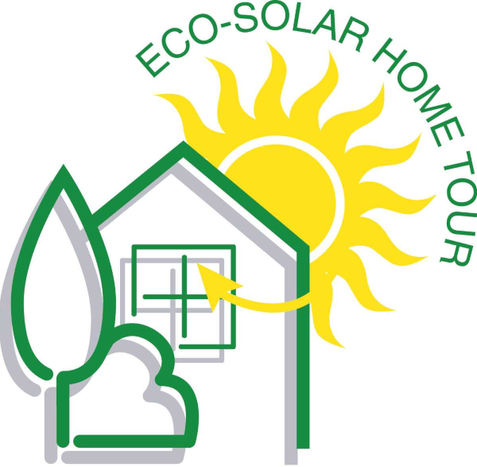

Please return this form by **January 31st, 2025.**

*Thanks for completing your application. I look forward to seeing your home on the tour. If you have any questions, please contact Andrew at*



**1. TOUR PRESENTER INFORMATION**

Tour City

* Edmonton (June 7&8)
* Calgary (June 14&15)
* Lethbridge (June 21)

Tour Day: Saturday Sunday Either

Address of the home:

* What is your neighborhood/community?
* Can people park on street? Yes No
  + Special Parking Instructions

Who is presenting this home on the tour?

*The primary contact is responsible for responding to all email requests.*

* Name of the primary contact
* Email of the primary contact
  + All emails will be sent to this person
* Cell phone of primary contact

Who are the homeowners?

* Name(s) of homeowner (as above, or)
* Email(s) of homeowner
* Cell phone(s) of homeowner

**2. HIGH-RESOLUTION PICTURES OF YOUR HOME**

We need 3 to **5** images of your home. These can be pictures or architectural drawings/renderings. At least one image should be of the front of your home.



Send pictures by separate email attachment to

DO NOT RE-SIZE. Do not place images in this document. Do not embed the pictures in a document or a PDF. Please do not send me a Dropbox link to thousands of pictures; pick 5 and send them to me by email attachment.

***Full-size high-resolution pictures as email attachments please.***

Getting pictures seems to be the most difficult part of setting up the tour.

**3. TOUR PRESENTER’S AGREEMENT ACKNOWLEDGEMENT**

*If you are offering your home for the tour, you need to acknowledge this agreement*

**Tour Presenter’s agreement:**

I understand that by applying to the Eco Solar Home Tour that I agree to host an open house on the agreed date and that I am responsible for the conduct of the tour at my house/building on tour day. The Eco Solar Home Tour Society will promote my open house using the information that I provide. The Eco Solar Home Tour Society has my permission to publish the address and representative pictures of my house/building on their web site and in other media to promote the tour. I agree that the Eco Solar Home Tour Society may take pictures of the house/building and any people on my property for the purposes of promoting the tour. *I understand that I will need to provide the people needed to run my open house and that a dedicated greeter is a requirement of the tour.* Information tables staffed by suppliers involved in building the house/building are encouraged but direct sales of goods or services are not permitted.

The Eco Solar Home Tour attempts to provide a positive and fair showcase of energy efficient technologies; *I understand that* *badmouthing or cutting down of competitive technologies or companies is against tour policy;* if I am not in favour of a particular technology then I will hold my comments and let others describe that technology.

I agree that promotional materials such as signs, flags, and other reusable items provided by the Eco Solar Home Tour Society will be returned promptly after the tour. I acknowledge that there is suitable insurance in place that will provide coverage for people that visit the open house.

In addition, builders agree that their company will be responsible for providing **safe access** for visitors on sites that are under construction. Builders also agree that they have the owner’s agreement (if the home is sold) to show the house on tour day.

**Since each home is private property, the homeowner (tour presenter) will ultimately be responsible for controlling the visitors on site.**

**I acknowledge that I have read and understand the 2025 Eco-Solar Home Tour agreement:**

**Tour presenter:**

**Homeowner(s):**

*Please add your email address to the lines above to indicate your agreement.*

*By returning this completed form to us you acknowledge that you agree to the above.*

**4.** **INFORMATION ON YOUR HOME**

**Energuide Rating:** **GJ/Year** *Provide your tested or estimated rating*

**Why is this home on the tour?**

*Tell us your story. Write a 150 to 200 word paragraph about your home…*

**What are the main things people see and learn about at your home?**

*Point form please. A summary of 5 or 6 points.*

**What are the main things people will see at your home?**

*What will people see when they visit your home? A bit more detail in point form please.*

**What features save on energy costs?**

*Insulation, air tightness, HRV, windows, solar, heat pump, appliances, etc.*

**What features save on water costs?**

*Efficient fixtures, toilets, Drain Water Heat Recovery, rain barrels*

**Other special features**

*Permaculture or garden features, electric car, special lifestyle practices, anything else?*